
Jaypee University of Information Technology, Waknaghat Solan H.P

Tutorial Sheet
Shortest Path Algorithms

Q1) Let $G$be a weighted directed acyclic graph with $m$edges and $n$vertices. Given $G$and a source vertex $s$in $G$, which one of the following options gives the worst case time complexity of the fastest algorithm to find the lengths of shortest paths from $s$ to all vertices that are reachable from $s$in $G?$

- Θ(m+n) | - $Θ\left(m+nlog⁡\left(n\right)\right)$
- $Θ\left(nm\right)$ | - Θ(n3)

Q2) Let $G\left(V , E\right)$be an undirected, edge-weighted graph with integer weights. The weight of a path is the sum of the weights of the edges in that path. The length of a path is the number of edges in that path.
Let $s∈V$be a vertex in $G$. For every $u∈V$and for every $k≥0$, let $d_{k}\left(u\right)$denote the weight of a shortest path (in terms of weight) from $s$to $u$ of length at most $k$. If there is no path from $s$to $u$of length at most $k$, then $d_{k}\left(u\right)=∞$.
Consider the statements:
S1: For every $k≥0$and $u∈V,d_{k+1}\left(u\right)≤d_{k}\left(u\right)$.
S2: For every $\left(u , v\right)∈E$, if $\left(u , v\right)$is part of a shortest path (in terms of weight) from $s$to $v$, then for every $k≥0,d_{k}\left(u\right)≤d_{k}\left(v\right)$.
Which one of the following options is correct?

- Only $\text{S1}$ is true | - Only $\text{S2}$ is true
- Both $\text{S1}$ and $\text{S2 }$are true | - Neither $\text{S1 }$nor $\text{S2 }$is true

Q3) Let $G$be an edge-weighted undirected graph with positive edge weights. Suppose a positive constant $α$ is added to the weight of every edge.
Which ONE of the following statements is TRUE about the minimum spanning trees (MSTs) and shortest paths (SPs) in $G$before and after the edge weight update?

- Every MST remains an MST, and every SP remains an SP. | - MSTs need not remain MSTs, and every SP remains an SP.
- Every MST remains an MST, and SPs need not remain SPs. | - MSTs need not remain MSTs, and SPs need not remain SPs.

Q4) Let $G\left(V , E\right)$be an undirected and unweighted graph with 100 vertices. Let $d\left(u , v\right)$denote the number of edges in a shortest path between vertices $u$and $v$ in $V$. Let the maximum value of $d\left(u , v\right)$, $u,v∈V$such that $u≠v$, be 30. Let $T$ be any breadth-first-search tree of $G$. Which ONE of the given options is CORRECT for every such graph $G$?

- The height of $T$is exactly 15. | - The height of $T$ is exactly 30.
- The height of $T$is at least 15. | - The height of $T$ is at least 30.

Q5) Let G = (V, E) be any connected undirected edge-weighted graph. The weights of the edges in E are positive and distinct. Consider the following statements:
(I) Minimum spanning tree of G is always unique.
(II) Shortest path between any two vertices of G is always unique.
Which of the above statements is/are necessarily true?

- (I) only | - (II) only
- Both (I) and (II) | - Neither (I) nor (II)

Q6) Consider the weighted undirected graph with 4 vertices, where the weigh to edge {i, j} is given by the entry W_{ij} in the matrix W.
$$W=\left[\begin{matrix}0 & 2 & 8 & 5 \\ 2 & 0 & 5 & 8 \\ 8 & 5 & 0 & x \\ 5 & 8 & x & 0\end{matrix}\right]$$The largest possible integer value of x, for which at least one shortest path between some pair of vertices will contain the edge with weight x is ____.

Q7) What is the time complexity of Bellman-Ford single-source shortest path algorithm on a complete graph of n vertices?

- Θ(n²) | - Θ(n²logn)
- Θ(n ³) | - $Θ\left(n^{3}logn\right)$

Q8) Consider the directed graph shown in the figure below. There are multiple shortest paths between vertices S and T. Which one will be reported by Dijkstra's shortest path algorithm? Assume that, in any iteration, the shortest path to a vertex v is updated only when a strictly shorter path to v is discovered
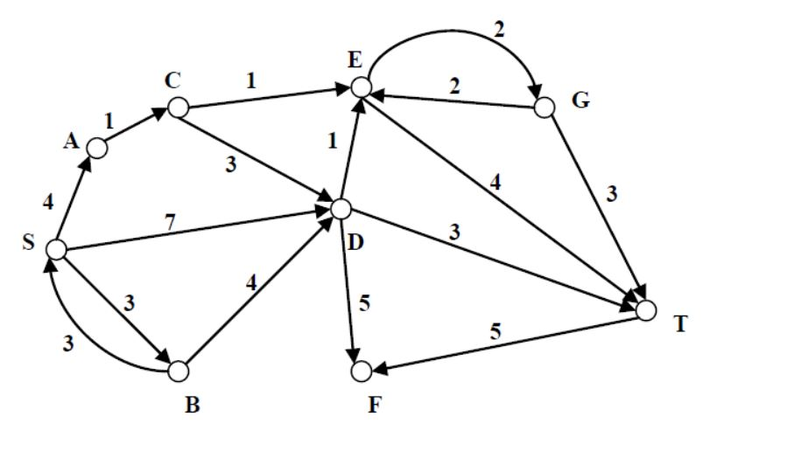

Q9) Compute shortest path from node 0 to node 8 using BFS algorithm.
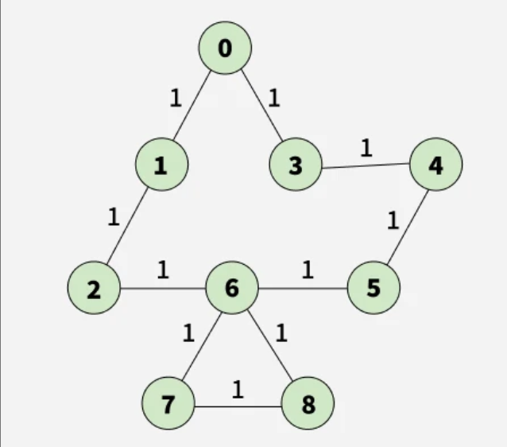
Q10) In the given graph, identify the path that has minimum cost to travel from node a to node f using Bellman-Ford algorithm.

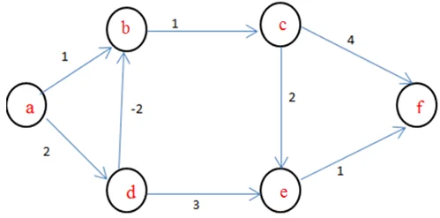

Q11) In the given graph, identify the path that has minimum cost to travel from node A to node F using Kahn’s algorithm.
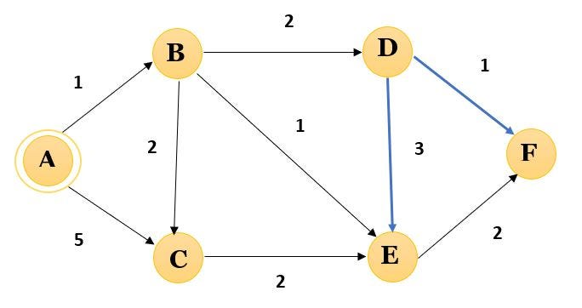

Q12) Determine the shortest path distance between all pair of nodes in the graph using Floyd Warshall Algorithm.
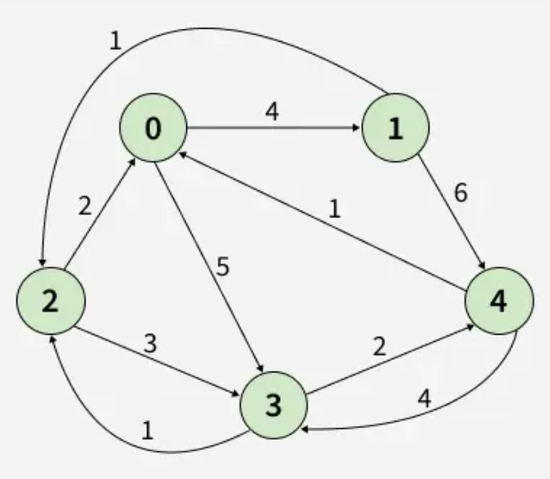

Q13) In the given graph, apply the first step of Johnson’s Algorithm to make all the weights non-negative.
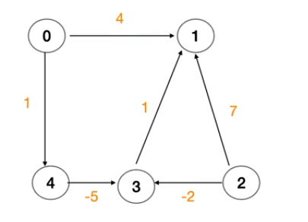

Q14) Let $G=\left(V , E\right)$be a directed, weighed graph with weight function $w:E→R$. For some function $f:V→R$, for each edge $\left(u , v\right)∈E$, define $w^{'}\left(u , v\right)$ as $w\left(u , v\right)+f\left(u\right)-f\left(v\right)$.
Which one of the options completes the following sentence so that it is TRUE?
"The shortest paths in G under $w$are shortest paths under $w^{' }$too, _________".

- for every $f:V→R$
- if and only if $∀u∈V,f\left(u\right)$ is positive
- if and only if $∀u∈V,f\left(u\right)$ is negative
- if and only if f(u) is the distance from s to u in the graph obtained by adding a new vertex s to G and edges of zero weight from s to every vertex of G

Q15) In the given graph i) calculate the heuristic value for each vertex [ Hint: use Euclidian distance between given vertices and Goal(G) ] ii) implement A* algorithm using calculated heuristic values to find shortest path from S to G.

